COGNITIVE TEST (1)
NAME: ___________________________________________ TOTAL: ____ /51
A. ABOUT GERMANY…..
1. The title of the leader of Germany until 1918 was _____________________ (1)
2. The German Parliament is called ___________________________________ (1)
3. The title of the head of the German Government is _____________________ (1)
4. German people in the south of the country were primarily protestant and wealthy farmers. T or F (1)
B. AFTER WORLD WAR ONE……
5. Name the peace treaty signed at the end of World War 1. ____________________________ (1)
6. List 3 clauses of this treaty and the way each effected Germany and its people. (3)
Treaty Clause | Impact on Germany

7. Define the following? (4)
(i) Weimar Government : _____________________________________________________________________
(ii) Spartacist Uprising: _______________________________________________________________________
(iii) Ruhr: __________________________________________________________________________________
(iv) Dawes Plan: _____________________________________________________________________________

8. Why is 1923 a “year of crisis”? ___________________________________________________________
___________________________________________________________________________________________________________________________________________________________________________________________________________________________________________________________________________________________________________________________________________________________________________________________________________________________________________________________________________________________________________________________________________________________________________(3)

9. Who are the following? (2)
(i) Ebert ________________________________________________________________________
(ii) Stresemann __________________________________________________________________
(iii) Hindenburg __________________________________________________________________
(iv) Mussolini ____________________________________________________________________
10. The Nazi Party struggled to gain seats in the Reichstag between 1925 and 1929. Why? (2)
- _________________________________________________________________________
- _________________________________________________________________________
C. The Great Depression
11. Explain how the following helped the Nazis during the Depression: (3)
  - Organisation ____________________________________________________________

  - Use of Technology _______________________________________________________

  - Propaganda ____________________________________________________________

12. Explain why these posters would appeal to many Germans in 1932. (2)
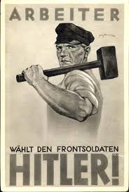
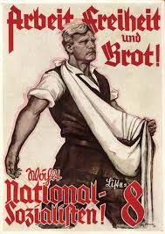

Work Freedom Bread! Worker – choose the front soldier…..
___________________________________________________________________________________________________________________________________________________________________________________________________________________________________________________________________________________________________________________________________________________________________________________
13. True or False?? (circle) (3)
  - The Nazis did better in getting support in rural areas than in urban areas during the Depression. T or F
  - They were more successful in the north than in the south of Germany. T or F

  - More Catholics supported the Nazis than Protestants. T or F
  - The working class in Germany saw the Nazis as their party. T or F
  - Middle class support of the Nazi Party fell during the Depression. T or F
  - The Nazis were the largest political party in the Reichstag by January 1933. T or F
D: Nazism
14. Match the person to their role in the Nazi Party. (3)
Hitler Roehm Himmler Goering Hess Goebbels
  - Leader of the SA - ____________________________________________
  - Leader of the SS - ____________________________________________
  - Propaganda Minister - _________________________________________
  - Leader of the Nazi Party - _______________________________________
  - Minister for the Interior - _______________________________________
  - Private Secretary to Hitler - _____________________________________
15. Who was von Papen? ______________________________________________________ (½ )
16. What do these terms mean? (6)
Ein Blud - _______________________________________________________________________
Ein Volk - _______________________________________________________________________
Ein Fuhrer - _____________________________________________________________________
The SA _________________________________________________________________________
The Swastika ___________________________________________________________________
Mein Kampf ____________________________________________________________________
17. Place the following events (by letter) in their correct position on the timeline below: (2 ½ )
(i) Emergency Decree (ii) Hitler is Chancellor (iii) Enabling Act (iv) Reichstag Fire
(v) March elections see Nazis win more seats than any other Party.
1933

January

February

March

April

18. What, exactly, did the Enabling Act actually enable the Nazis to do? ___________________________________________________________________________________________________________________________________________________________________________________________________________________________________________________________________________________(2)
19. What is Gleischaltung? ___________________________________________________________ ( ½ )
20. Why was gleischaltung needed? _________________________________________________________
________________________________________________________________________________________(1 ½ )
21. What happened to the following during 1933? (6)
  - Social Democrats (SPD) _________________________________________________
  - Trade Unions _________________________________________________________
  - The Reichstag ________________________________________________________
  - Jews ________________________________________________________________
  - Books by people the fascists hated ________________________________________
  - Van der Lubbe ________________________________________________________
22. What point is the cartoonist missing about the situation in Germany in this cartoon?
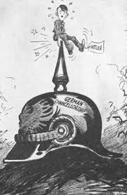
American cartoon from 1933.
“Not the most comfortable seat.”

______________________________________________________
______________________________________________________
______________________________________________________
______________________________________________________
________________________________________________ (1)

E. FASCISM
23. If you lived in a fascist state…. (circle correct answer) (1)
I you would not be allowed to own a private business
II you could be imprisoned for expressing a view that opposed the government
III you would belong to a government run trade union
IV you would idealise your country’s leader
- I, II and III only
- II, III and IV only
- I and III only
- I and IV only
End of Test

